

DATA STRUCTURE AND ALGORITHM
23CSE203
LAB MANUAL

SUBMITTED BY
NAME | G. HEMA HARSHINI
ROLL NO | AV.SC.U4CSE25108
YEAR/SEM/SECTION | 2ST YEAR/SEM-3/CSE-B
CREDITS | 05

SUBMITTED TO
NAME | DR.RAJ KUMAR BATCHU
DESIGNATION | ASST.PROFFESSOR(S1. Grade)
DEPARTMENT | SCHOOL OF COMPUTING

INDEX
S.NO | PROGRAM | PAGE NO | REMARKS
1. | WEEK 1:  1a) A rocket launch displays a countdown before launch. Instead of using a loop, implement the countdown using recursion. Write a recursion python program to display a countdown from n to 1, followed by “Launch!”.  1b) Banks calculate the growth of an investment using compound interest. The formula requires calculating powers, which can be implemented recursively, write a recursive program to calculate p^n (power) where:  p=principal growth factor, n=no. of years.  1c) An HR department stores employee IDs in a list. Develop a recursive program to search for a given employee ID. Write a recursive function search for an employee ID in a list.  1d) In a logistics company, the no of possible ways to arrange n different parcels are calculated using the factorial formula(n!). Develop a recursive program to calculate the factorial of a given number.  1e) Write a recursive python program to print the 1st ‘n’ terms of Fibonacci series.
2. | WEEK 2:  2a) Write a python program to implement linear search.  2b)  (i) Write a python program to implement binary search with sorted array as an input.  (ii) Write a python program to implement binary search without sorted array as an input.
3. | WEEK 3:  3a) Write a python program to implement bubble sort by taking the input.  3b) Write a python program to implement insertion sort by taking the input.  3c) Write a python program to implement selection sort by taking the input.

WEEK-1
1a) AIM: A rocket launch displays a countdown before launch. Instead of using a loop, implement the countdown using recursion. Write a recursion python program to display a countdown from n to 1, followed by “Launch!”.
CODE:
def countdown(n):
if n == 1:
print(1)
print("Launch!")
else:
print(n)
countdown(n - 1)

n = int(input("Enter the countdown number: "))
countdown(n)
OUTPUT(+VE):
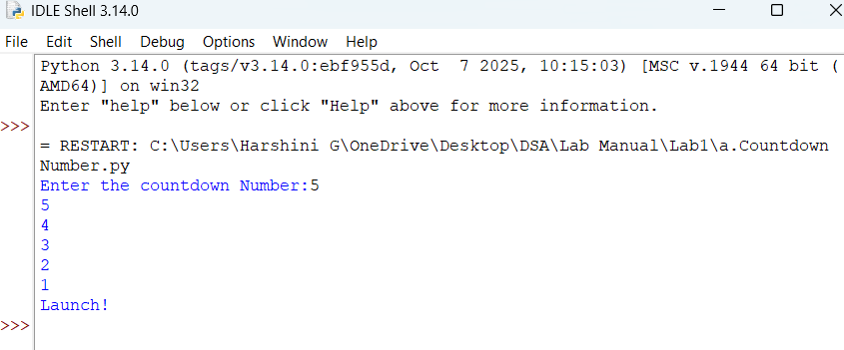
OUTPUT(-VE):
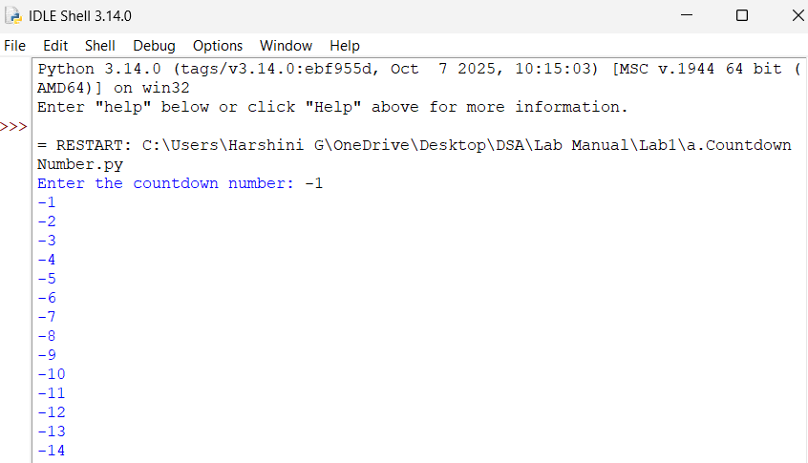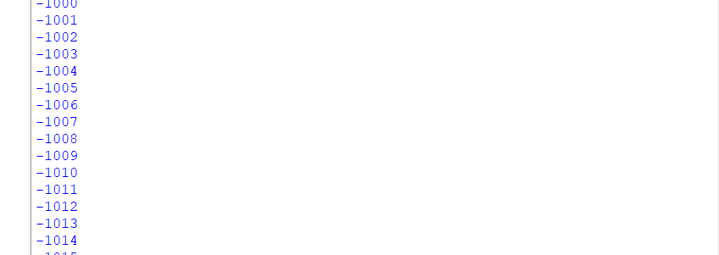
Error Table:
Edge Case | Input | Error | Explanation
Negative Number | n== -1 | Infinte Recursive Error | The value keeps becoming smaller: -1, -2, -3, .... It never reaches 1, so recursion does not stop.

Explanation:
- Define the function: A function named countdown() is created. It takes n as the input.
- If is the base case of the recursion. When n becomes 1, then function displays the statement in the print() function.
- If n is not 1: function displays the statement in the print() function. The function calls itself with n - 1.
- countdown(n): This calls the function using the number entered by the user.
1b) AIM: Banks calculate the growth of an investment using compound interest. The formula requires calculating powers, which can be implemented recursively, write a recursive program to calculate p^n (power) where:
p=principal growth factor, n=no. of years.
CODE:
def power(p, n):
if n == 0:
return 1
else:
return p * power(p, n - 1)

p = float(input("Enter the principal growth factor: "))
n = int(input("Enter the number of years: "))
result = power(p, n)
print("Power =", result)
OUTPUT(+VE):
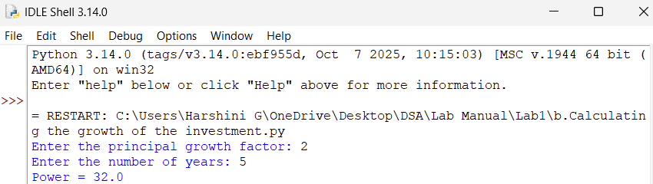
OUTPUT(-VE):
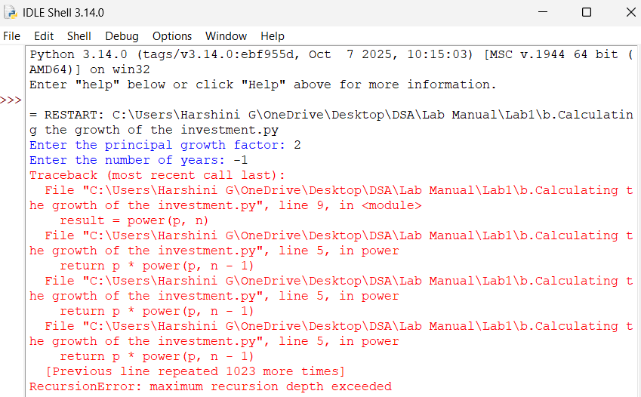
Error Table:
Edge Case | Input | Error | Explanation
Negative Number n | P==2,n== -1 | Infinte Recursive Error | n keeps decreasing: -1, -2, -3..., so it never reaches the base case n=0.
Explanation:
- Define the function: A function named power() is created. It takes p and n as the input.
- If is the base case of the recursion. When n becomes 1, then function displays the statement in the print() function.
- If n is not 0, the function calls itself with n - 1.
- The function is called using the values entered by the user.
1c) AIM: An HR department stores employee IDs in a list. Develop a recursive program to search for a given employee ID. Write a recursive function search for an employee ID in a list.
CODE:
def search(ids, key, index):
if index == len(ids):
return -1
if ids[index] == key:
return index
return search(ids, key, index + 1)
ids = [101, 205, 310, 415, 520]
key = int(input("Enter employee ID to search: "))
result = search(ids, key, 0)
if result != -1:
print("Employee ID found at position:", result)
else:
print("Value is not found")
OUTPUT(+VE):
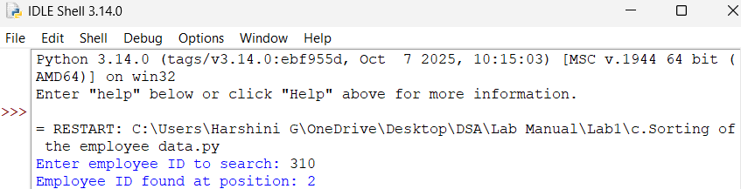
OUTPUT(-VE):
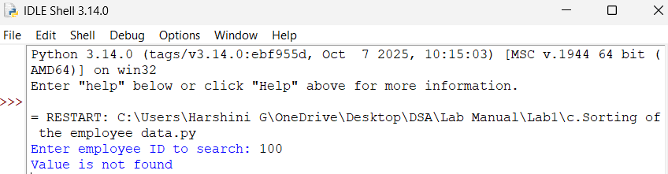
Error Table:
Edge Case | Input | Error | Explanation
ID not found | 100 | Value is not found | 100 is not present in the list.
Explanation:
- Define the function: A function named search() is created. It takes key as the input.
- If is the base case of the recursion. When result not becomes -1, then function displays the statement in the print() function.
- If result is not -1, the function displays the statement in the print() function.
1d) AIM: In a logistics company, the no of possible ways to arrange n different parcels are calculated using the factorial formula(n!). Develop a recursive program to calculate the factorial of a given number.
CODE:
def factorial(n):
if n == 0 or n == 1:
return 1
return n * factorial(n - 1)
n = int(input("Enter number of parcels: "))
if n < 0:
print(f"The factorial of {n} is not defined")
else:
print("Number of possible arrangements of parcels:", factorial(n))
OUTPUT(+VE):
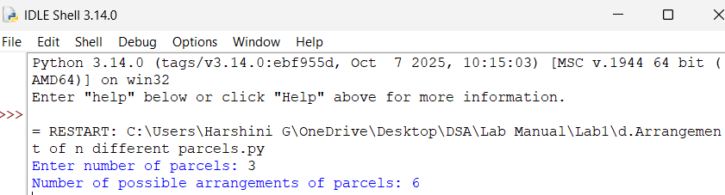
OUTPUT(-VE):
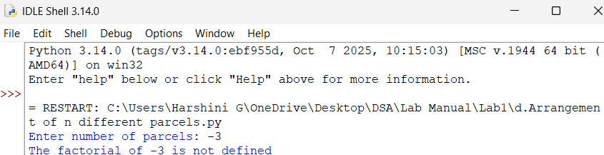
Error Table:
Edge Case | Input | Error | Explanation
Negative number | -3 | It is not defined | -3 is not present in the factorial.
Explanation:
- Define the function: A function named factorial() is created. It takes n as the input.
- If is the base case of the recursion. When n becomes 0 or 1, then function displays the statement in the print() function.
- If n is not 0 or 1, the function displays the statement in the print() function.
1e) AIM: Write a recursive python program to print the 1st ‘n’ terms of Fibonacci series.
CODE:
def fibonacci(n):
if n <= 1:
return n
return fibonacci(n - 1) + fibonacci(n - 2)
n = int(input("Enter number: "))
print("Fibonacci Series:")
for i in range(n):
print(fibonacci(i), end=" ")
OUTPUT(+VE):
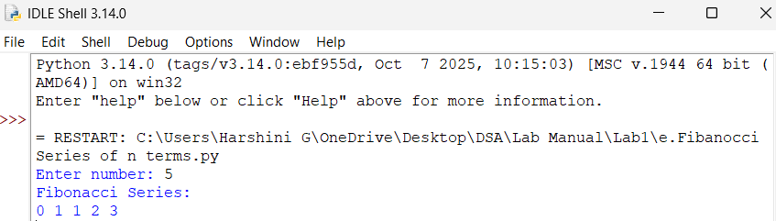
OUTPUT(-VE):
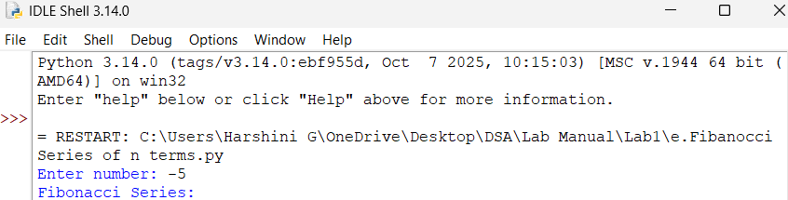

Error Table:
Edge Case | Input | Error | Explanation
Negative number | -5 | No series | -5 is not number to start the present in the series.
Explanation:
- Define the function: A function named fibanocci() is created. It takes n as the input.
- If is the base case of the recursion. When n becomes less than 1, then it returns n.
- If n is not less than 1, then it returns the function of the factorial of n-1 and n -2.
- If for i in the range then display the fibanocci series.
WEEK-2
2a) AIM: Write a python program to implement linear search.
CODE:
arr = [10, 20, 30, 40, 50]
key = int(input("Enter the element to search [10-50]: "))
position = -1
for i in range(len(arr)):
if arr[i] == key:
position = i
break
if position != -1:
print("Element found at position:", position + 1)
else:
print("Element not found")
OUTPUT(+VE):
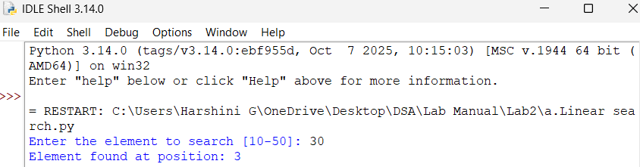
OUTPUT(-VE):
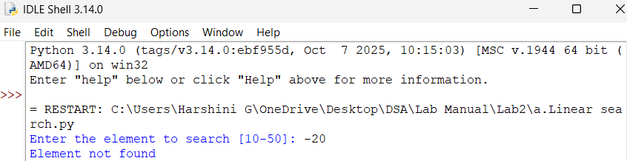
Error Table:
Edge Case | Input | Error | Explanation
Negative number | -20 | Element is not in the list | -20 is not in the list.
Explanation:
- Take the input of the array. It takes key as the input.
- If for i in the range then display the functions in it.
- If is the base case of the recursion. When position is not 1, then function displays the statement in the print() function.
- If n is not 1, then function displays the statement in the print() function.
2b)
i) AIM: Write a python program to implement binary search with sorted array as an input.
CODE:
n = int(input("Enter the number of elements: "))
arr = []
print("Enter elements in sorted order:")
for i in range(n):
arr.append(int(input("Enter element: ")))
key = int(input("Enter element to search: "))
low = 0
high = n - 1
while low <= high:
mid = (low + high) // 2
if arr[mid] == key:
print("Element found at position:", mid)
break
elif arr[mid] < key:
low = mid + 1
else:
high = mid - 1
else:
print("Element not found")
OUTPUT(+VE):
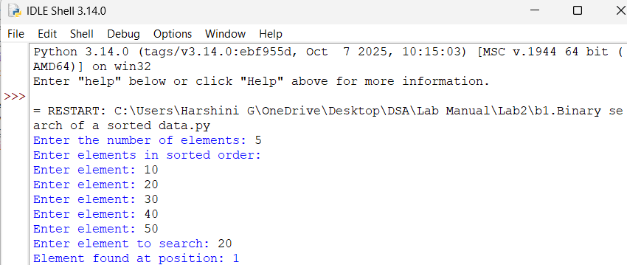
OUTPUT(-VE):
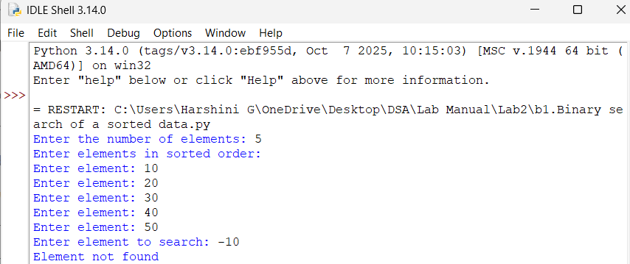
Error Table:
Edge Case | Input | Error | Explanation
Negative number | -10 | Element is not in the list | -10 is not in the list.
Explanation:
1. The program takes the number of elements and then takes the elements of the array as input. The elements must be entered in sorted order.
2. The program takes the value key that has to be searched in the sorted array.
3. The variables low and high are initialized. low = 0 represents the first position, and high = n - 1 represents the last position of the array.
4. The program calculates the middle position using: mid = (low + high) // 2
5. If arr[mid] == key, the element is found and its position is displayed using the print() function.
6. If arr[mid] < key, the key may be present in the right half of the array. Therefore, low is changed to mid + 1.
7. If arr[mid] > key, the key may be present in the left half of the array. Therefore, high is changed to mid - 1.
8. The while low <= high condition repeatedly searches the middle portion until the element is found or there are no more elements to search.
9. If the key is found, the program displays "Element found at position". If the search finishes without finding the key, the program displays "Element not found".
ii) AIM: Write a python program to implement binary search without sorted array as an input.
CODE:
n = int(input("Enter the number of elements: "))
arr = []
for i in range(n):
arr.append(int(input("Enter element: ")))
arr.sort()
key = int(input("Enter element to search: "))
low = 0
high = n - 1
while low <= high:
mid = (low + high) // 2
if arr[mid] == key:
print("Element found at position:", mid)
break
elif arr[mid] < key:
low = mid + 1
else:
high = mid - 1
else:
print("Element not found")
OUTPUT(+ VE):
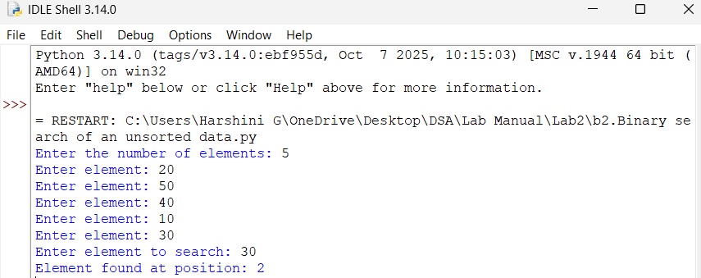
OUTPUT(-VE):
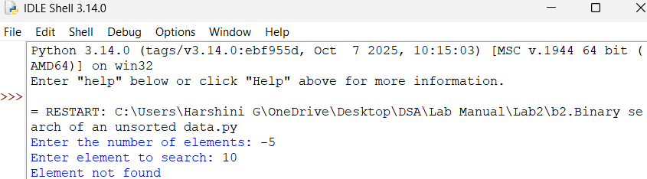
Error Table:
Edge Case | Input | Error | Explanation
Negative number | -5 | Element is not found | -5 is a negative number
Explanation:
1. The program first takes the number of elements and then takes the elements of the array from the user. The elements do not need to be entered in sorted order.
2. The sort() function is used to arrange the elements in ascending order.
arr.sort()
This is necessary because binary search works only on a sorted array.
3. After sorting, the program displays the sorted array using the print() function.
4. The program takes the value key that needs to be searched in the array.
5. The variables low and high are initialized. low = 0 represents the first position, and high = n - 1 represents the last position.
6. The middle position is calculated using:
mid = (low + high) // 2
7. If arr[mid] == key, the element is found and its position is displayed using the print() function.
8. If arr[mid] < key, the key may be present in the right half. Therefore:
low = mid + 1
9. If arr[mid] > key, the key may be present in the left half. Therefore:
high = mid - 1
10. The while low <= high loop continues dividing the search area into half until the key is found or there are no more elements to search.
11. If the key is found, the program displays "Element found at position". If the key is not found, it displays "Element not found".
WEEK-3
3a) AIM: Write a python program to implement bubble sort by taking the input.
CODE:
def bubble_sort(arr):
n=len(arr)
for i in range(n-1):
for j in range(n-i-1):
if arr[j]>arr[j+1]:
arr[j],arr[j+1]=arr[j+1],arr[j]
return arr
n=int(input("Enter the number of elements:"))
arr=[]
print("Enter elements: ")
for i in range(n):
arr.append(int(input()))
print("Sorted array:", bubble_sort(arr))
key = int(input("Enter the element to search: "))
if key in arr:
print("Element found")
else:
print("Element not found")
OUTPUT(+VE):
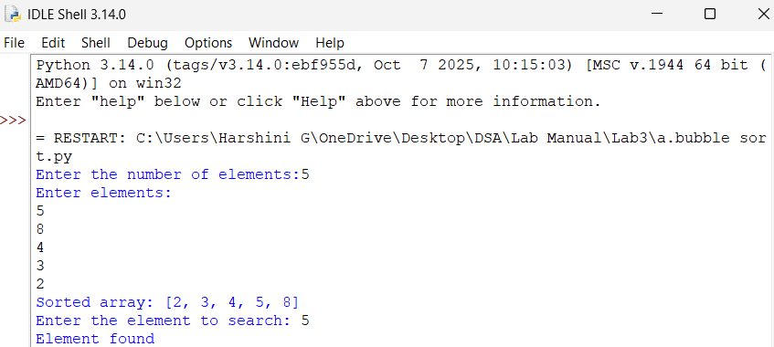
OUTPUT(-VE):
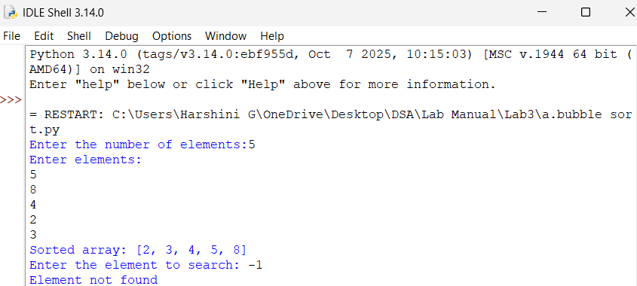
ERROR OBSERVATION:
Invalid syntax: ‘,’ is not entered and there is syntax error.
Error Table:
Edge Case | Input | Error | Explanation
Negative number | -1 | Element is not found | -1 is a negative number
Explanation:
1. The program first takes the number of elements n and then takes each element from the user using a for loop. The elements are stored in the list arr.
2. The outer for loop controls the number of passes required to sort the array.
for i in range(n - 1):
3. The inner loop compares two neighboring elements of the array.
for j in range(n - 1 - i):
4. If the current element is greater than the next element:
if arr[j] > arr[j + 1]:
the two elements need to be exchanged.
5. The elements are swapped using:
arr[j], arr[j + 1] = arr[j + 1], arr[j]
This moves the larger element toward the end of the array.
6. The inner loop continues comparing adjacent elements. After every pass, the largest unsorted element moves to its correct position at the end.
7. The outer loop continues until all elements are arranged in ascending order.
8. After sorting is completed, the program displays the sorted list
3b) AIM: Write a python program to implement insertion sort by taking the input.
CODE:
n = int(input("Enter the number of elements: "))
arr = []
for i in range(n):
arr.append(int(input("Enter element: ")))
for i in range(1, n):
key = arr[i]
j = i - 1
while j >= 0 and arr[j] > key:
arr[j + 1] = arr[j]
j = j - 1
arr[j + 1] = key
print("Sorted list:", arr)
OUTPUT(+VE):
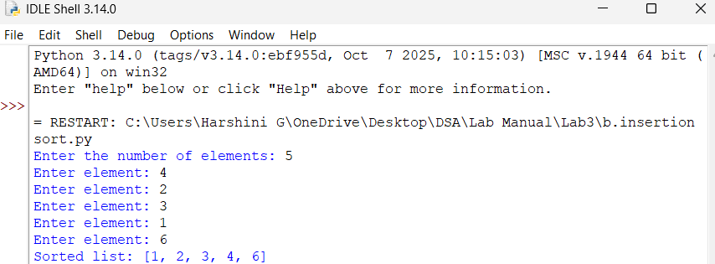
OUTPUT(-VE):
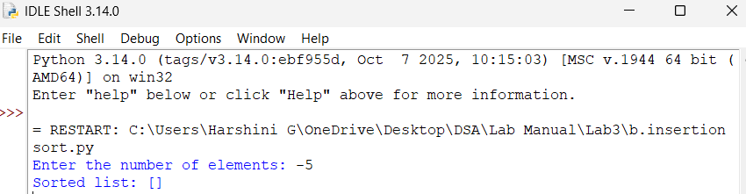
ERROR OBSERVATION:
Invalid syntax: there is an indentation error.
Error Table:
Edge Case | Input | Error | Explanation
Negative number | -5 | Element is not found | -5 is a negative number
Explanation:
1. The program first takes the number of elements n and then takes each element from the user. The elements are stored in the list arr.
2. The for loop starts from index 1 because the first element is considered already sorted.
3. The current element is stored in the variable key.
key = arr[i]
This is the element that needs to be inserted into its correct position.
4. The variable j is set to the position just before the key.
j = i - 1
5. The while loop checks whether the previous element is greater than the key.
while j >= 0 and arr[j] > key:
6. If arr[j] is greater than key, it is moved one position to the right.
arr[j + 1] = arr[j]
Then j is decreased by 1 to check the next element.
7. When the correct position is found, the key is inserted using:
arr[j + 1] = key
8. The for loop continues with the next element. At each step, the sorted portion of the array becomes larger.
9. After all elements have been inserted into their correct positions, the program displays
3c) AIM: Write a python program to implement selection sort by taking the input.
CODE:
n = int(input("Enter the number of elements: "))
arr = []
for i in range(n):
arr.append(int(input("Enter element: ")))
for i in range(n - 1):
min_index = i
for j in range(i + 1, n):
if arr[j] < arr[min_index]:
min_index = j
arr[i], arr[min_index] = arr[min_index], arr[i]
print("Sorted list:", arr)
OUTPUT(+VE):
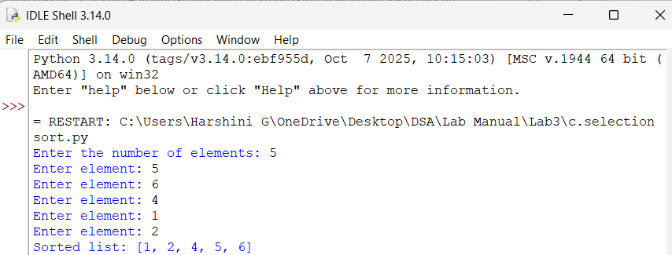
OUTPUT(-VE):
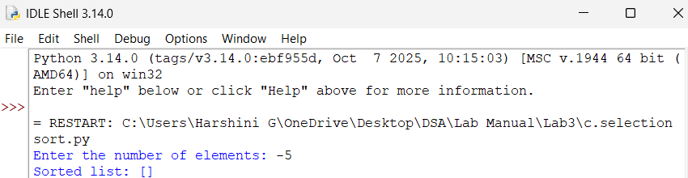
Error Table:
Edge Case | Input | Error | Explanation
Negative number | -5 | Element is not found | -5 is a negative number
Explanation:
1. The program takes the number of elements and then takes each element from the user and stores them in the list arr.
2. The outer for loop selects the current position i and assumes that the element at this position is the smallest.
min_index = i
3. The inner loop compares the selected element with all the elements to its right.
if arr[j] < arr[min_index]:
min_index = j
4. Whenever a smaller element is found, its index is stored in min_index.
5. After finding the smallest element, it is exchanged with the element at position i.
arr[i], arr[min_index] = arr[min_index], arr[i]
6. The outer loop moves to the next position and repeats the same process until all elements are arranged in ascending order.
7. After sorting is completed, the program displays the sorted list.
WEEK-4
4a) AIM: Write a python program to implement merge sort.
INPUT:
def merge_sort(arr):
#the base condition
if len(arr)<=1:
return arr
#dividing the array
mid=len(arr)//2
left=arr[:mid]
right=arr[mid:]
#recurssive calls
merge_sort(left)
merge_sort(right)
i=0
j=0
k=0
#merging the two sorted halves
while i<len(left) and j<len(right):
if left[i]<=right[j]:
arr[k]=left[i]
i+=1
else:
arr[k]=right[j]
j+=1
k+=1
#copy the remaining elements of left array
while i<len(left):
arr[k]=left[i]
i+=1
k+=1
#copy the remaining elements of right array
while j<len(right):
arr[k]=right[j]
j+=1
k+=1
#enter the input
n=int(input("Enter the number of elements: "))
arr=[]
print("Enter the numbers:")
for i in range(n):
arr.append(int(input()))
#function call
merge_sort(arr)
#printing the outputs
print("Merged array",arr)
OUTPUT(+VE):
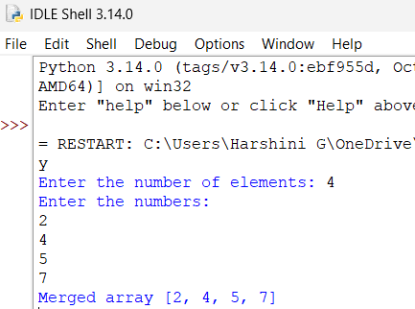
OUTPUT(-VE):
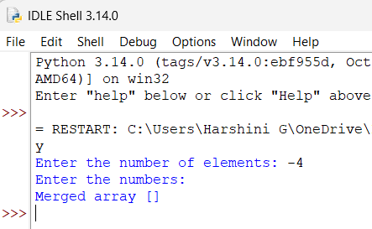
Error Table:
Explanation:

4b) AIM: Write a python program to implement quick sort.
INPUT:
def quick_sort(a, low, high):
#the base condition
if low < high:
i = low
j = high
pivot = low
while i < j:
#element greater than or equal to the pivot
while i <= high and a[i] <= a[pivot]:
i += 1
#element smaller than the pivot
while a[j] > a[pivot]:
j -= 1
if i < j:
a[i], a[j] = a[j], a[i]
#placing the pivots in the positions
a[pivot], a[j] = a[j], a[pivot]
#recurrively sortng the left and right parts
quick_sort(a, low, j - 1)
quick_sort(a, j + 1, high)
#enter the inputs
a = list(map(int, input("Enter numbers to sort: ").split()))
n = len(a)
#function call
quick_sort(a, 0, n - 1)
#printing the output
print("Sorted array:")
print(a)
OUTPUT(+VE):
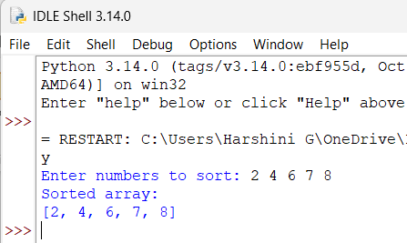
OUTPUT(-VE):
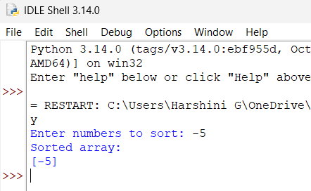
Error Table:
Explanation:

WEEK-5
5a) AIM: Write a python program to implement Singly Linked list with the below operation:
i.Create Linked List
ii.Insert beginning
iii.Insert end
iv.Insert at index
v.Delete by value
vi.Delete first node
vii.Delete last node
viii.Count no.of nodes
ix.Exit
INPUT:
class Node:
def __init__(self, data):
self.data=data
self.next=None
class SinglyLinkedList:
def __init__(self):
self.head=None

def create(self):
n=int(input("Enter number of elements:"))
for i in range(n):
x=int(input("Enter the value:"))
new=Node(x)
if self.head is None:
self.head=new
else:
temp=self.head
while temp.next:
temp=temp.next
temp.next=new

def insert_begin(self,data):
new=Node(data)
new.next=self.head
self.head=new

def insert_end(self,data):
new=Node(data)
if self.head is None:
self.head=new
else:
temp=self.head
while temp.next:
temp=temp.next
temp.next=new

def insert_index(self,index,data):
if index==0:
self.insert_begin(data)
return
elif index>self.count():
print("Invalid index")
return
new=Node(data)
temp=self.head
for i in range(index-1):
temp=temp.next
new.next=temp.next
temp.next=new

def delete_Beg(self):
if self.head is None:
print("No data to delete")
else:
temp=self.head
self.head=temp.next
print("Deleted value=",temp.data)

def delete_End(self):
if self.head is None:
print("No data to delete")
elif self.head.next is None:
self.head=None
else:
temp=self.head
temp1=temp
while temp.next:
temp1=temp
temp=temp.next
temp1.next=None

def delete(self,value):
if self.head is None:
printf("No data to delete")
else:
temp=self.head
if temp and temp.data==value:
self.head=temp.next
print("Value deleted")
return
while temp.next and temp.next.data!=value:
temp=temp.next
if temp.next is None:
print("Value not present")
else:
temp.next=temp.next.next
print("Value is deleted")

def count(self):
if self.head is None:
print("No linked List")
else:
c=0
temp=self.head
while temp:
c=+1
temp=temp.next
print(f"Number of nodes={c}")

sll=SinglyLinkedList()
while True:
print("1.Create a Singly Linked List")
print("2.Insert at beginning using Single Linked List")
print("3.Insert at end using Single Linked List")
print("4.Insert at index using Single Linked List")
print("5.Delete at first node using Single Linked List")
print("6.Delete at last node using Single Linked List")
print("7.Delete by value using Single Linked List")
print("8.Count number of nodes using Single Linked List")
print("9.Exit")
choice=int(input("Enter the choice:"))
if choice==1:
sll.create()
elif choice==2:
x=int(input("Value:"))
sll.insert_begin(x)
elif choice==3:
x=int(input("Value:"))
sll.insert_end(x)
elif choice==4:
idx=int(input("Index:"))
x=int(input("Value:"))
sll.insert_index(idx,x)
elif choice==5:
x=int(input("Delete value:"))
sll.delete_beg(x)
elif choice==6:
sll.delete_end()
elif choice==7:
sll.delete()
elif choice==8:
sll.count()
elif choice==9:
print("The program is exiting")
break
else:
print("Enter a vaild choice")
OUTPUT(+VE):
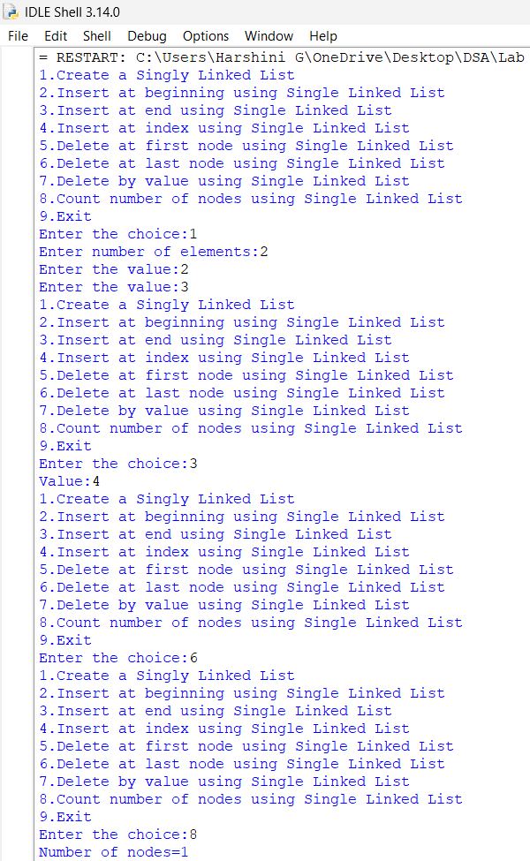
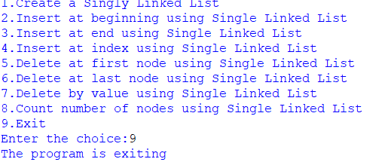
OUTPUT(-VE):
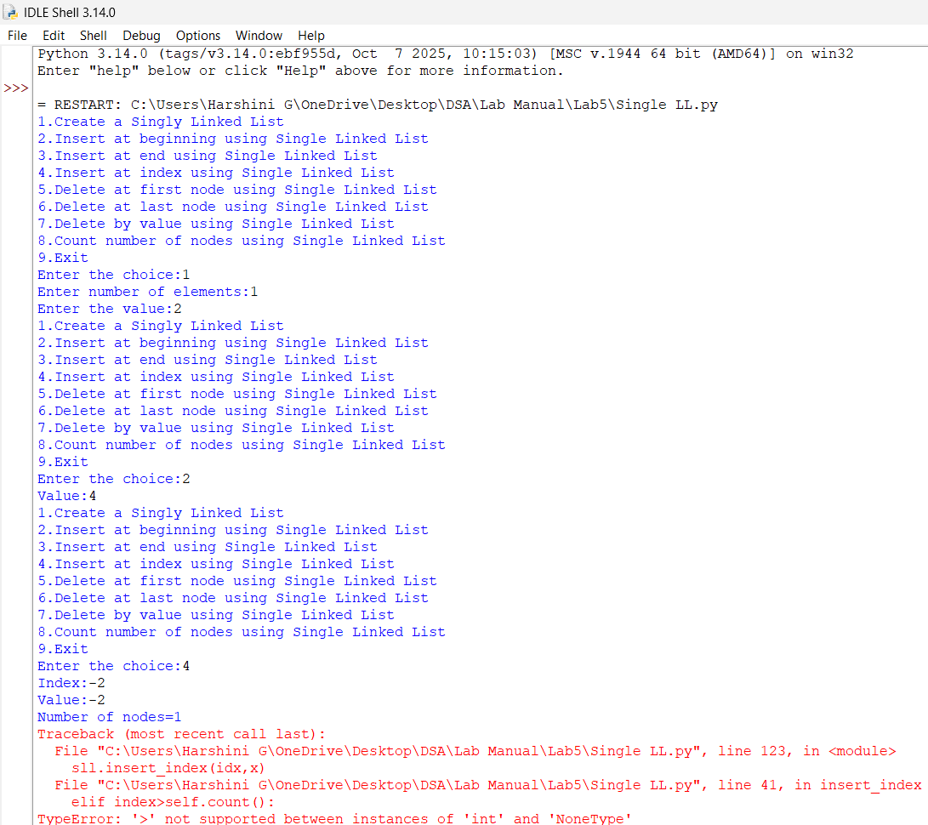
Error Table:
Explanation:

5b) AIM: Write a python program to implement a Doubly Linked list with the below operations:
i.Insert beginning
ii.Insert end
iii.Insert at index
iv.Delete by value
v.Delete first node
vi.Delete last node
vii.Count no.of nodes
viii.Exit
INPUT:
class Node:
def __init__(self, data):
self.prev = None
self.data = data
self.next = None

class DoublyLinkedList:
def __init__(self):
self.head = None

def insert_begin(self, data):
new = Node(data)

if self.head is None:
self.head = new
else:
new.next = self.head
self.head.prev = new
self.head = new

print("Insertion completed")

def insert_end(self, data):
new = Node(data)

if self.head is None:
self.head = new
else:
temp = self.head

while temp.next:
temp = temp.next

temp.next = new
new.prev = temp

print("Insertion completed")

def insert_index(self, index, data):
if index < 0:
print("Invalid index")
return

if index == 0:
self.insert_begin(data)
return

if self.head is None:
print("Invalid index")
return

temp = self.head

for i in range(index - 1):
if temp is None:
print("Invalid index")
return

temp = temp.next

if temp is None:
print("Invalid index")
return

new = Node(data)

new.next = temp.next
new.prev = temp

if temp.next is not None:
temp.next.prev = new

temp.next = new

print("Insertion completed")

def deleteBeg(self):
if self.head is None:
print("Can't perform delete operation")
return

temp = self.head
self.head = self.head.next

if self.head is not None:
self.head.prev = None

print("Value deleted =", temp.data)

def deleteEnd(self):
if self.head is None:
print("Can't perform delete operation")
return

temp = self.head

if temp.next is None:
self.head = None
print("Value deleted =", temp.data)
return

while temp.next:
temp = temp.next

print("Value deleted =", temp.data)

temp.prev.next = None
temp.prev = None

def deleteIndex(self, index):
if self.head is None:
print("Can't perform delete operation")
return

if index < 0:
print("Invalid index")
return

if index == 0:
self.deleteBeg()
return

temp = self.head

for i in range(index):
if temp is None:
print("Invalid index")
return

temp = temp.next

if temp is None:
print("Invalid index")
return

if temp.prev is not None:
temp.prev.next = temp.next

if temp.next is not None:
temp.next.prev = temp.prev

print("Value deleted =", temp.data)

def count(self):
c = 0
temp = self.head

while temp:
c += 1
temp = temp.next

print(f"Number of nodes = {c}")

dll = DoublyLinkedList()

while True:
print("1. Insert at beginning")
print("2. Insert at end")
print("3. Insert at index")
print("4. Delete at first node")
print("5. Delete at last node")
print("6. Delete at index")
print("7. Count number of nodes")
print("8. Exit")
choice = int(input("Enter the choice: "))
if choice == 1:
x = int(input("Value: "))
dll.insert_begin(x)
elif choice == 2:
x = int(input("Value: "))
dll.insert_end(x)
elif choice == 3:
idx = int(input("Index: "))
x = int(input("Value: "))
dll.insert_index(idx, x)
elif choice == 4:
dll.deleteBeg()
elif choice == 5:
dll.deleteEnd()
elif choice == 6:
idx = int(input("Delete index: "))
dll.deleteIndex(idx)
elif choice == 7:
dll.count()
elif choice == 8:
print("The program is exiting")
break
else:
print("Enter a valid choice")
OUTPUT(+VE):
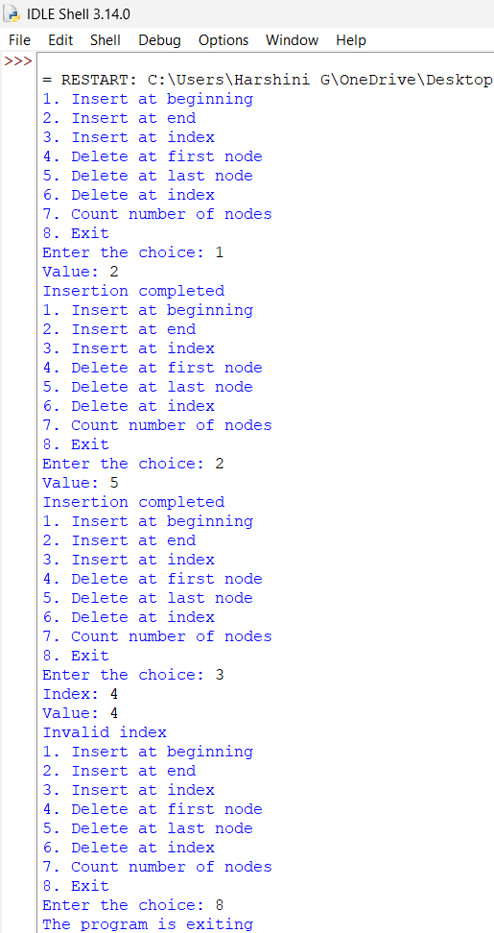
OUTPUT(-VE):
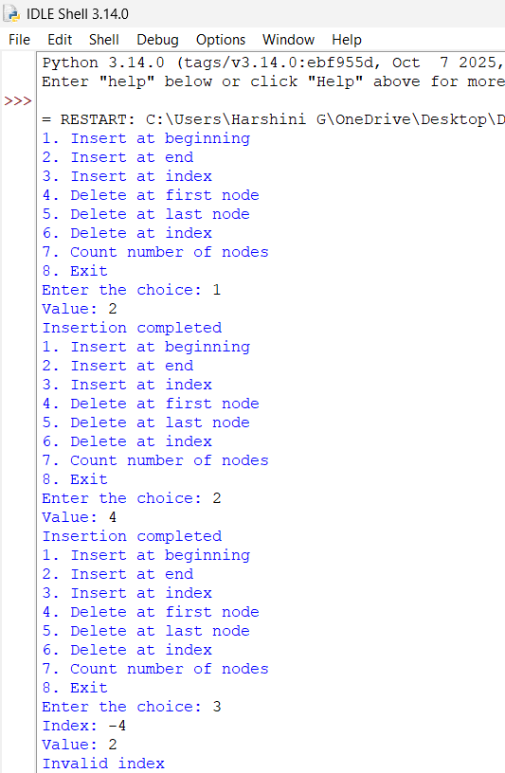
Error Table:
Explanation:

5c) AIM: Write a python program to implement a Circulated Linked list with the given operations:
i.Insert beginning
ii.Insert end
iii.Insert at index
iv.Delete by value
v.Delete first node
vi.Delete last node
vii.Count no.of nodes
viii.Exit
INPUT:
class Node:
def __init__(self, data):
self.data = data
self.next = None
class CircularLinkedList:
def __init__(self):
self.head = None
self.tail = None

def insert_begin(self, data):
new = Node(data)

if self.head is None:
self.head = new
self.tail = new
new.next = self.head
else:
new.next = self.head
self.head = new
self.tail.next = self.head

print("Insertion completed")

def insert_end(self, data):
new = Node(data)

if self.head is None:
self.head = new
self.tail = new
new.next = self.head
else:
new.next = self.head
self.tail.next = new
self.tail = new

print("Insertion completed")

def insert_position(self, position, data):
if position < 0:
print("Invalid position")
return

if position == 0:
self.insert_begin(data)
return

if self.head is None:
print("Invalid position")
return

temp = self.head

for i in range(position - 1):
temp = temp.next

if temp == self.head:
print("Invalid position")
return

new = Node(data)
new.next = temp.next
temp.next = new

if temp == self.tail:
self.tail = new

print("Insertion completed")

def delete_begin(self):
if self.head is None:
print("List is empty")
return

if self.head == self.tail:
print("Deleted value =", self.head.data)
self.head = None
self.tail = None
else:
print("Deleted value =", self.head.data)
self.head = self.head.next
self.tail.next = self.head

def delete_end(self):
if self.head is None:
print("List is empty")
return

if self.head == self.tail:
print("Deleted value =", self.tail.data)
self.head = None
self.tail = None
return

temp = self.head

while temp.next != self.tail:
temp = temp.next

print("Deleted value =", self.tail.data)

temp.next = self.head
self.tail = temp

def delete_position(self, position):
if self.head is None:
print("List is empty")
return

if position < 0:
print("Invalid position")
return

if position == 0:
self.delete_begin()
return

temp = self.head

for i in range(position - 1):
temp = temp.next

if temp == self.head:
print("Invalid position")
return

if temp.next == self.head:
print("Invalid position")
return

delete_node = temp.next

if delete_node == self.tail:
self.tail = temp

temp.next = delete_node.next

print("Deleted value =", delete_node.data)

def count(self):
if self.head is None:
print("Number of nodes = 0")
return

c = 0
temp = self.head

while True:
c += 1
temp = temp.next

if temp == self.head:
break

print("Number of nodes =", c)

cll = CircularLinkedList()
while True:
print("1. Insert at beginning")
print("2. Insert at end")
print("3. Insert at index")
print("4. Delete at first node")
print("5. Delete at last node")
print("6. Delete at index")
print("7. Count number of nodes")
print("8. Exit")
choice = int(input("Enter the choice: "))
if choice == 1:
x = int(input("Value: "))
cll.insert_begin(x)
elif choice == 2:
x = int(input("Value: "))
cll.insert_end(x)
elif choice == 3:
idx = int(input("Index: "))
x = int(input("Value: "))
cll.insert_position(idx, x)
elif choice == 4:
cll.delete_begin()
elif choice == 5:
cll.delete_end()
elif choice == 6:
idx = int(input("Delete index: "))
cll.delete_position(idx)
elif choice == 7:
cll.count()
elif choice == 8:
print("The program is exiting")
break
else:
print("Enter a valid choice")
OUTPUT(+VE):
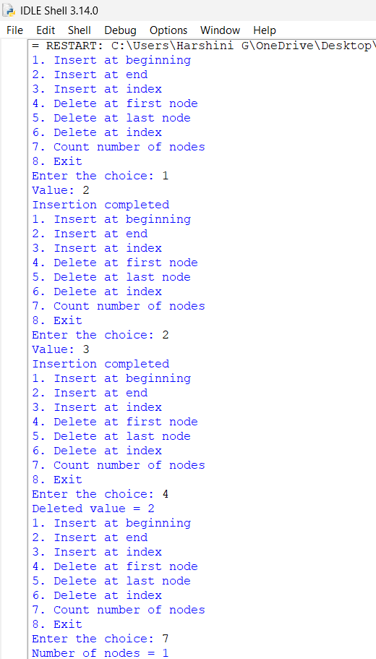
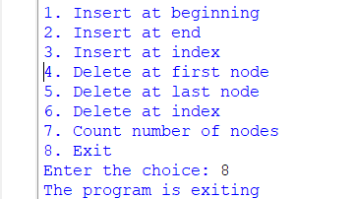
OUTPUT(-VE):
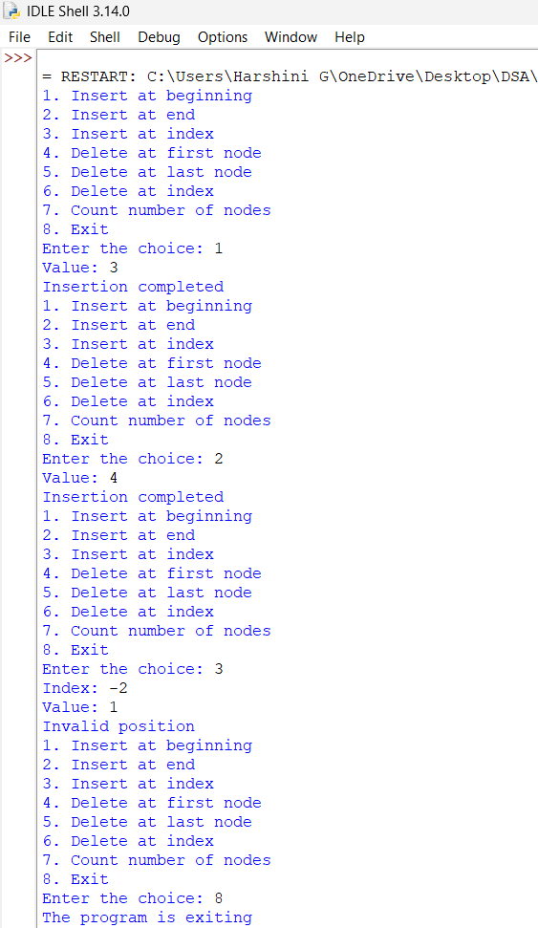
Error Table:
Explanation:
1.The program creates nodes containing data and a next pointer, with tail.next always pointing to head to maintain the circular structure.
2. insert_begin(), insert_end(), and insert_position() add new nodes at the beginning, end, or specified position.
3. delete_begin(), delete_end(), and delete_position() remove nodes from the beginning, end, or specified position.
4. The head and tail pointers are updated after every insertion or deletion to maintain the circular connection.
5. The count() and display() functions traverse the list and stop when the pointer reaches head again.
6. The menu-driven program allows the user to perform these operations repeatedly until the Exit option is selected.
WEEK-6
6a) AIM: Write a python program to implement stack operations such as push(),pop(),peek().Display() using an array.
INPUT:
class stack:
def __init__(self,size):
self.size=size
self.stack=[None]*size
self.top=-1

def push(self,data):
if self.top==self.size-1:
print("Stack Overflow")
else:
self.top+=1
self.stack[self.top]=item
print(item,"pushed into the stack")

def pop(self):
if self.top is None:
print("Stack underflow")
else:
item=self.stack[self.top]
self.stack[self.top]=None
self.top-=1
print(item,"popped from the stack")

def peek(self):
if self.top==-1:
print("Stack is empty")
else:
print("Top element:",self.stack[self.top])

def display(self):
if self.top==-1:
print("Stack is empty")
else:
print("The elements of the stack are:")
for i in range(self.top,-1,-1):
print(self.stack[i])

size=int(input("Enter the size of the stack:"))
s=stack(size)
while True:
print("1.Push() using Array")
print("2.Pop() using Array")
print("3.Peek() using Array")
print("4.Display() using Array")
print("5.Exit")
choice=int(input("Enter the choice:"))
if choice==1:
item=int(input("Enter the element to push:"))
s.push(item)
elif choice==2:
s.pop()
elif choice==3:
s.peek()
elif choice==4:
s.display()
elif choice==5:
print("The program is exiting")
break
else:
print("Enter a vaild choice")
OUTPUT(+VE):
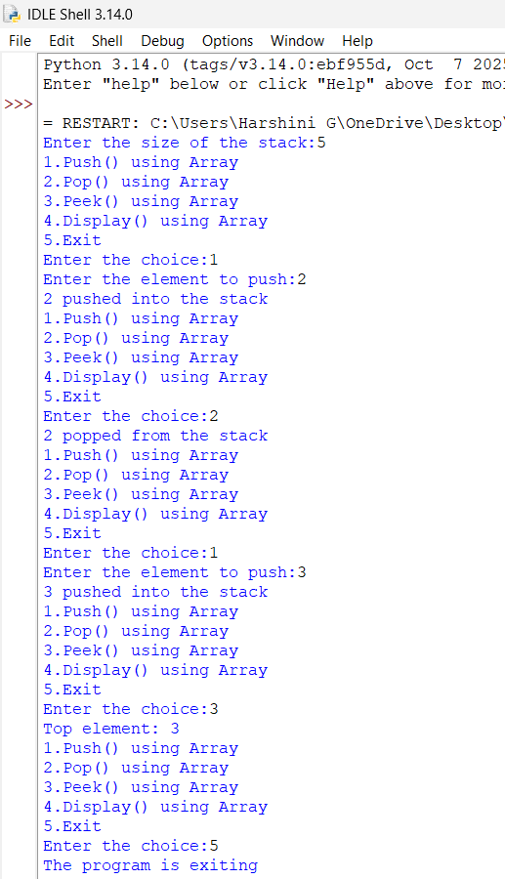
OUTPUT(-VE):
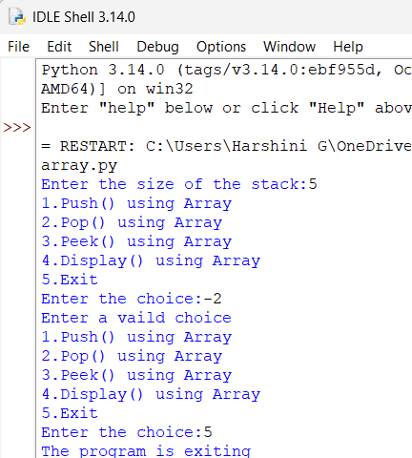
Error Table:
Explanation:

6b) AIM: Write a python program to implement stack operations such as push(),pop(),peek().Display() using an Linked list.
INPUT:
class Node:
def __init__(self,data):
self.data=data
self.next=None
class stack:
def __init__(self):
self.top=None

def push(self,data):
new=Node(data)
new.next=self.top
self.top=new
print(data,"pushed into stack")

def pop(self):
if self.top is None:
print("Stack Underflow")
else:
temp=self.top
print(temp.data,"popped from stack")
self.top=self.top.next

def peek(self):
if self.top is None:
print("Stack is empty")
else:
print("Top element:",self.top.data)

def display(self):
if self.top is None:
print("Stack is empty")
else:
temp=self.top
print("Stack elements")
while temp is not None:
print(temp.data)
temp=temp.next

s=stack()
while True:
print("1.Push() using Linked List")
print("2.Pop() using Linked List")
print("3.Peek() using Linked List")
print("4.Display() using Linked List")
print("5.Exit")
choice=int(input("Enter the choice:"))
if choice==1:
data=int(input("Enter the value:"))
s.push(data)
elif choice==2:
s.pop()
elif choice==3:
s.peek()
elif choice==4:
s.display()
elif choice==5:
print("The program is exiting")
break
else:
print("Enter a vaild choice")
OUTPUT(+VE):
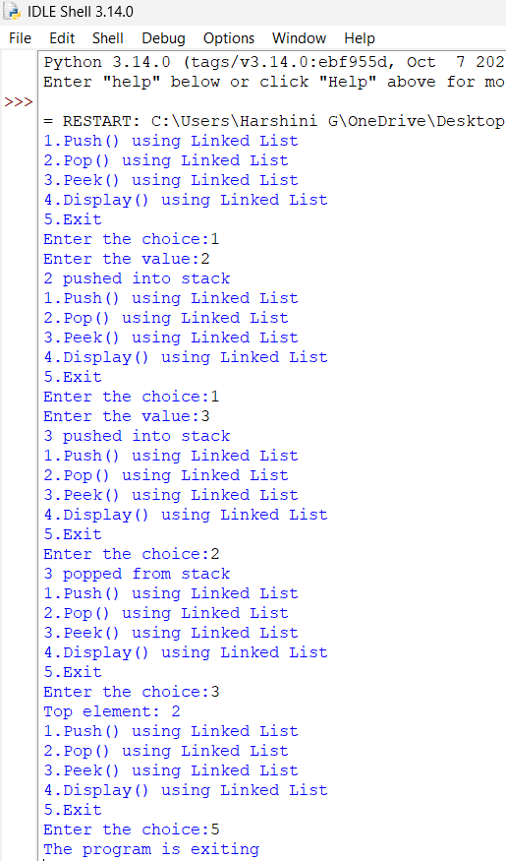
OUTPUT(-VE):
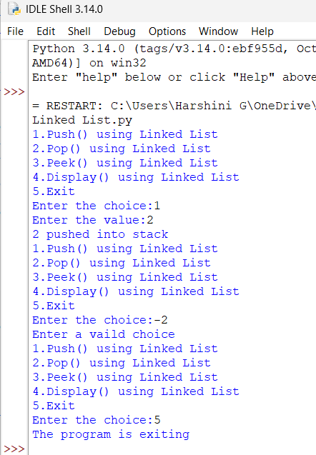
Error Table:
Explanation:
WEEK-7
7a) AIM: Write a python program to implement a queue and its operations such as enqueue,dequeue,peek and display with a menu driven approach.Implement using array.
INPUT:
class Queue:
def __init__(self,size):
self.size=size
self.queue=[None]*size
self.front=-1
self.rear=-1

def enqueue(self,x):
if self.rear==self.size-1:
print("Queue Overflow")
else:
if self.front==-1:
self.front=0
self.rear+=1
self.queue[self.rear]=x
print(f"{x} inserted into queue")

def dequeue(self):
if self.front==-1 or self.front>self.rear:
print("Queue Underflow")
else:
x=self.queue[self.front]
self.queue[self.front]=None
self.front+=1
print(f"{x} deleted from the queue")
if self.front>self.rear:
self.front= -1
self.rear= -1

def peek(self):
if self.front==-1:
print("Queue is empty")
else:
print("Front element:",self.queue[self.front])

def display(self):
if self.front==-1:
print("Queue is empty")
else:
print("The elements of the queue are:")
for i in range(self.front,self.rear+1):
print(self.queue[i])

size=int(input("Enter the size of queue:"))
q=Queue(size)
while True:
print("1.Enqueue")
print("2.Dequeue")
print("3.Peek")
print("4.Display")
print("5.Exit")
choice=int(input("Enter your choice:"))
if choice==1:
x=int(input("Enter the element to enqueue:"))
q.enqueue(x)
elif choice==2:
q.dequeue()
elif choice==3:
q.peek()
elif choice==4:
q.display()
elif choice==5:
print("Program is terminating")
break
else:
print("Enter vaild choice")
OUTPUT(+VE):
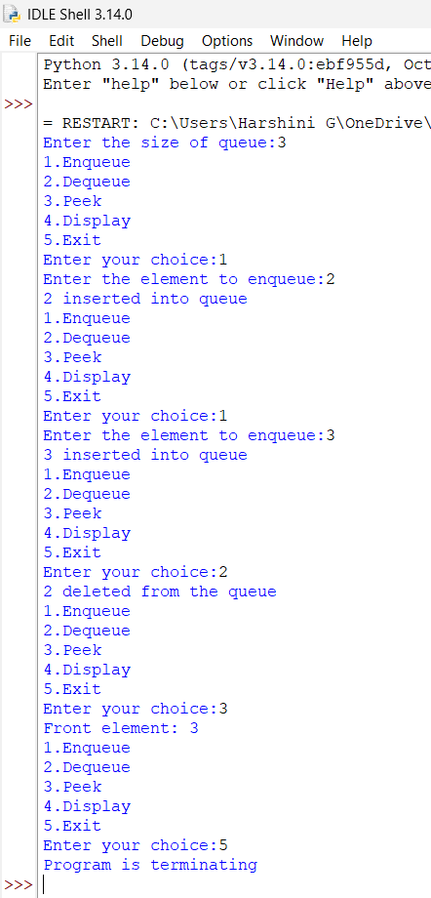
OUTPUT(-VE):
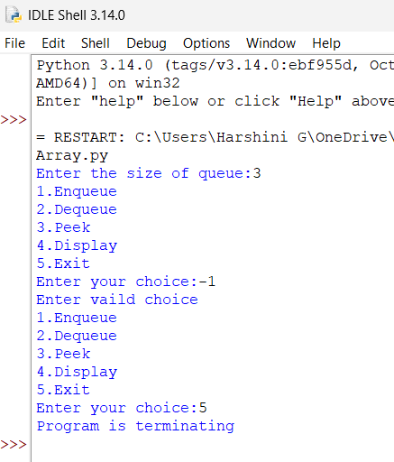
Error table:
Explanation:
- The program creates a queue using an array, with front and rear variables to track the first and last elements.
- The enqueue() function inserts an element at the rear and displays Queue Overflow when the array is full.
- The dequeue() function removes the element from the front and displays Queue Underflow when the queue is empty.
- When all elements are deleted, both front and rear are reset to -1.
- The peek() function displays the front element, while display() prints all elements from front to rear.
- The menu-driven program allows enqueue, dequeue, peek, and display operations until the user selects Exit.

7b) AIM: Write a python program to implement a queue and its operations such as enqueue,dequeue,peek and display with a menu driven approach.Implement using Singly Linked list.
INPUT:
class Node:
def __init__(self,data):
self.data=data
self.next=None

class Queue:
def __init__ (self):
self.front=None
self.rear=None

def enqueue(self,x):
new=Node(x)
if self.rear is None:
self.front=self.rear=new
else:
self.rear.next=new
self.rear=new
print(x,"inserted into the queue.")

def dequeue(self):
if self.front is None:
print("Queue Underflow")
else:
x=self.front.data
self.front=self.front.next
if self.front is None:
self.rear=None
print(f"{x} deleted from the queue")

def peek(self):
if self.front is None:
print("Queue is empty")
else:
print("Front element:",self.front.data)

def display(self):
if self.front is None:
print("Queue is empty")
else:
print("The elements of the queue are:")
temp=self.front
while temp is not None:
print(temp.data)
temp=temp.next
q=Queue()
while True:
print("1.Enqueue")
print("2.Dequeue")
print("3.Peek")
print("4.Display")
print("5.Exit")
choice=int(input("Enter your choice:"))
if choice==1:
x=int(input("Enter the element to enqueue:"))
q.enqueue(x)
elif choice==2:
q.dequeue()
elif choice==3:
q.peek()
elif choice==4:
q.display()
elif choice==5:
print("Program is exiting")
break
else:
print("Enter a vaild choice")
OUTPUT(+VE):
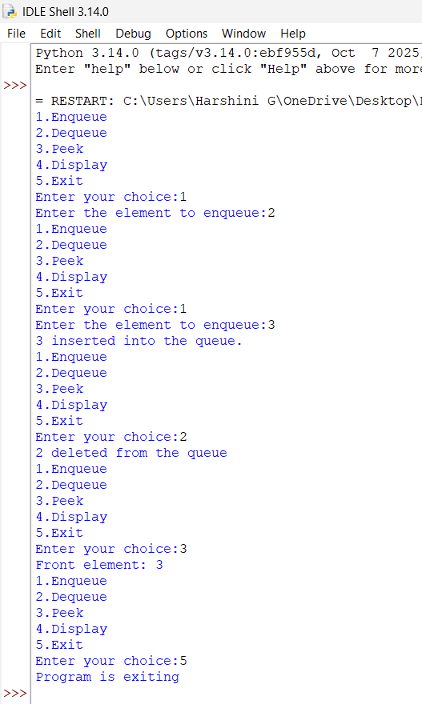
OUTPUT(-VE):
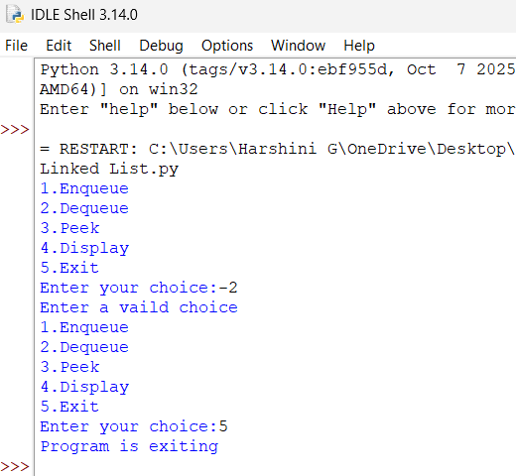
Error table:
Explanation:
1.The program creates a Node class with data and next to store elements and link them together.
2. The Queue class uses front and rear pointers to keep track of the first and last nodes.
3. The enqueue() function creates a new node and adds it at the rear of the queue.
4. The dequeue() function removes the node from the front and displays Queue Underflow if the queue is empty.
5. The peek() function displays the front element, while display() traverses the linked list and prints all queue elements.
6. The menu-driven program allows the user to perform enqueue, dequeue, peek, and display operations until Exit is selected.

7c) AIM: Write a python program to implement a queue and its operations such as enqueue,dequeue,peek and display with a menu driven approach.Implement using Circulated queue.
INPUT:
class CircularQueue:
def __init__(self, size):
self.size = size
self.queue = [None] * size
self.front = -1
self.rear = -1

def enqueue(self, item):
if (self.rear + 1) % self.size == self.front:
print("Queue Overflow")
elif self.front == -1:
self.front = 0
self.rear = 0
self.queue[self.rear] = item
print(item, "inserted into the queue")
else:
self.rear = (self.rear + 1) % self.size
self.queue[self.rear] = item
print(item, "inserted into the queue")

def dequeue(self):
if self.front == -1:
print("Queue Underflow")
elif self.front == self.rear: # Only one element
item = self.queue[self.front]
self.queue[self.front] = None
self.front = -1
self.rear = -1
print(item, "deleted from the queue")
else: # More than one element
item = self.queue[self.front]
self.queue[self.front] = None
self.front = (self.front + 1) % self.size
print(item, "deleted from the queue")

def display(self):
if self.front == -1:
print("Queue is empty")
else:
print("The elements of the queue are:")
i = self.front
while True:
print(self.queue[i])
if i == self.rear:
break
i = (i + 1) % self.size
def peek(self):
if self.front == -1:
print("Queue is empty")
return None
else:
print("Front element is:", self.queue[self.front])
return self.queue[self.front]

# Menu-driven program
size = int(input("Enter the size of the queue: "))
q = CircularQueue(size)
while True:
print("1. Enqueue")
print("2. Dequeue")
print("3. Peek")
print("4. Display")
print("5. Exit")
choice = int(input("Enter your choice: "))
if choice == 1:
item = int(input("Enter the element to enqueue: "))
q.enqueue(item)
elif choice == 2:
q.dequeue()
elif choice == 3:
q.peek()
elif choice == 4:
q.display()
elif choice == 5:
print("Program terminated.")
break
else:
print("Invalid choice")
OUTPUT(+VE):
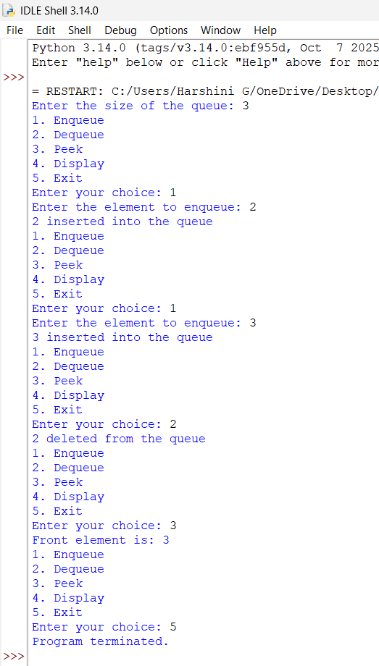
OUTPUT(-VE):
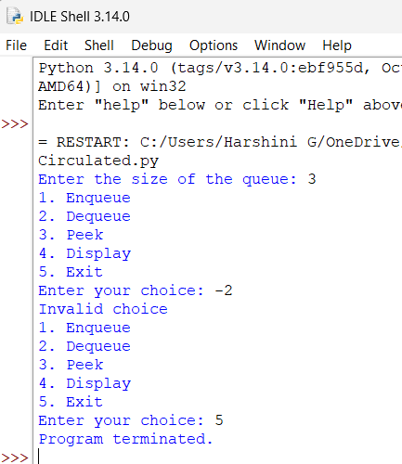
Error table:
Explanation:
- The program creates a circular queue using an array, with front and rear pointers to track the first and last elements.
- The enqueue() function inserts an element and uses modulo % size to move rear circularly.
- If the next position of rear is equal to front, the queue is full and Queue Overflow is displayed.
- The dequeue() function removes the front element and updates front; if the queue is empty, Queue Underflow is displayed.
- The peek() function displays the front element, while display() prints all elements by traversing circularly from front to rear.
- The menu-driven program allows the user to perform enqueue, dequeue, peek, and display operations until Exit is selected.

